**The initial tests**

**1. Hardware:**

- **NodeMCU ESP-32S – microcontrollers (2)**

Pinout (home made):

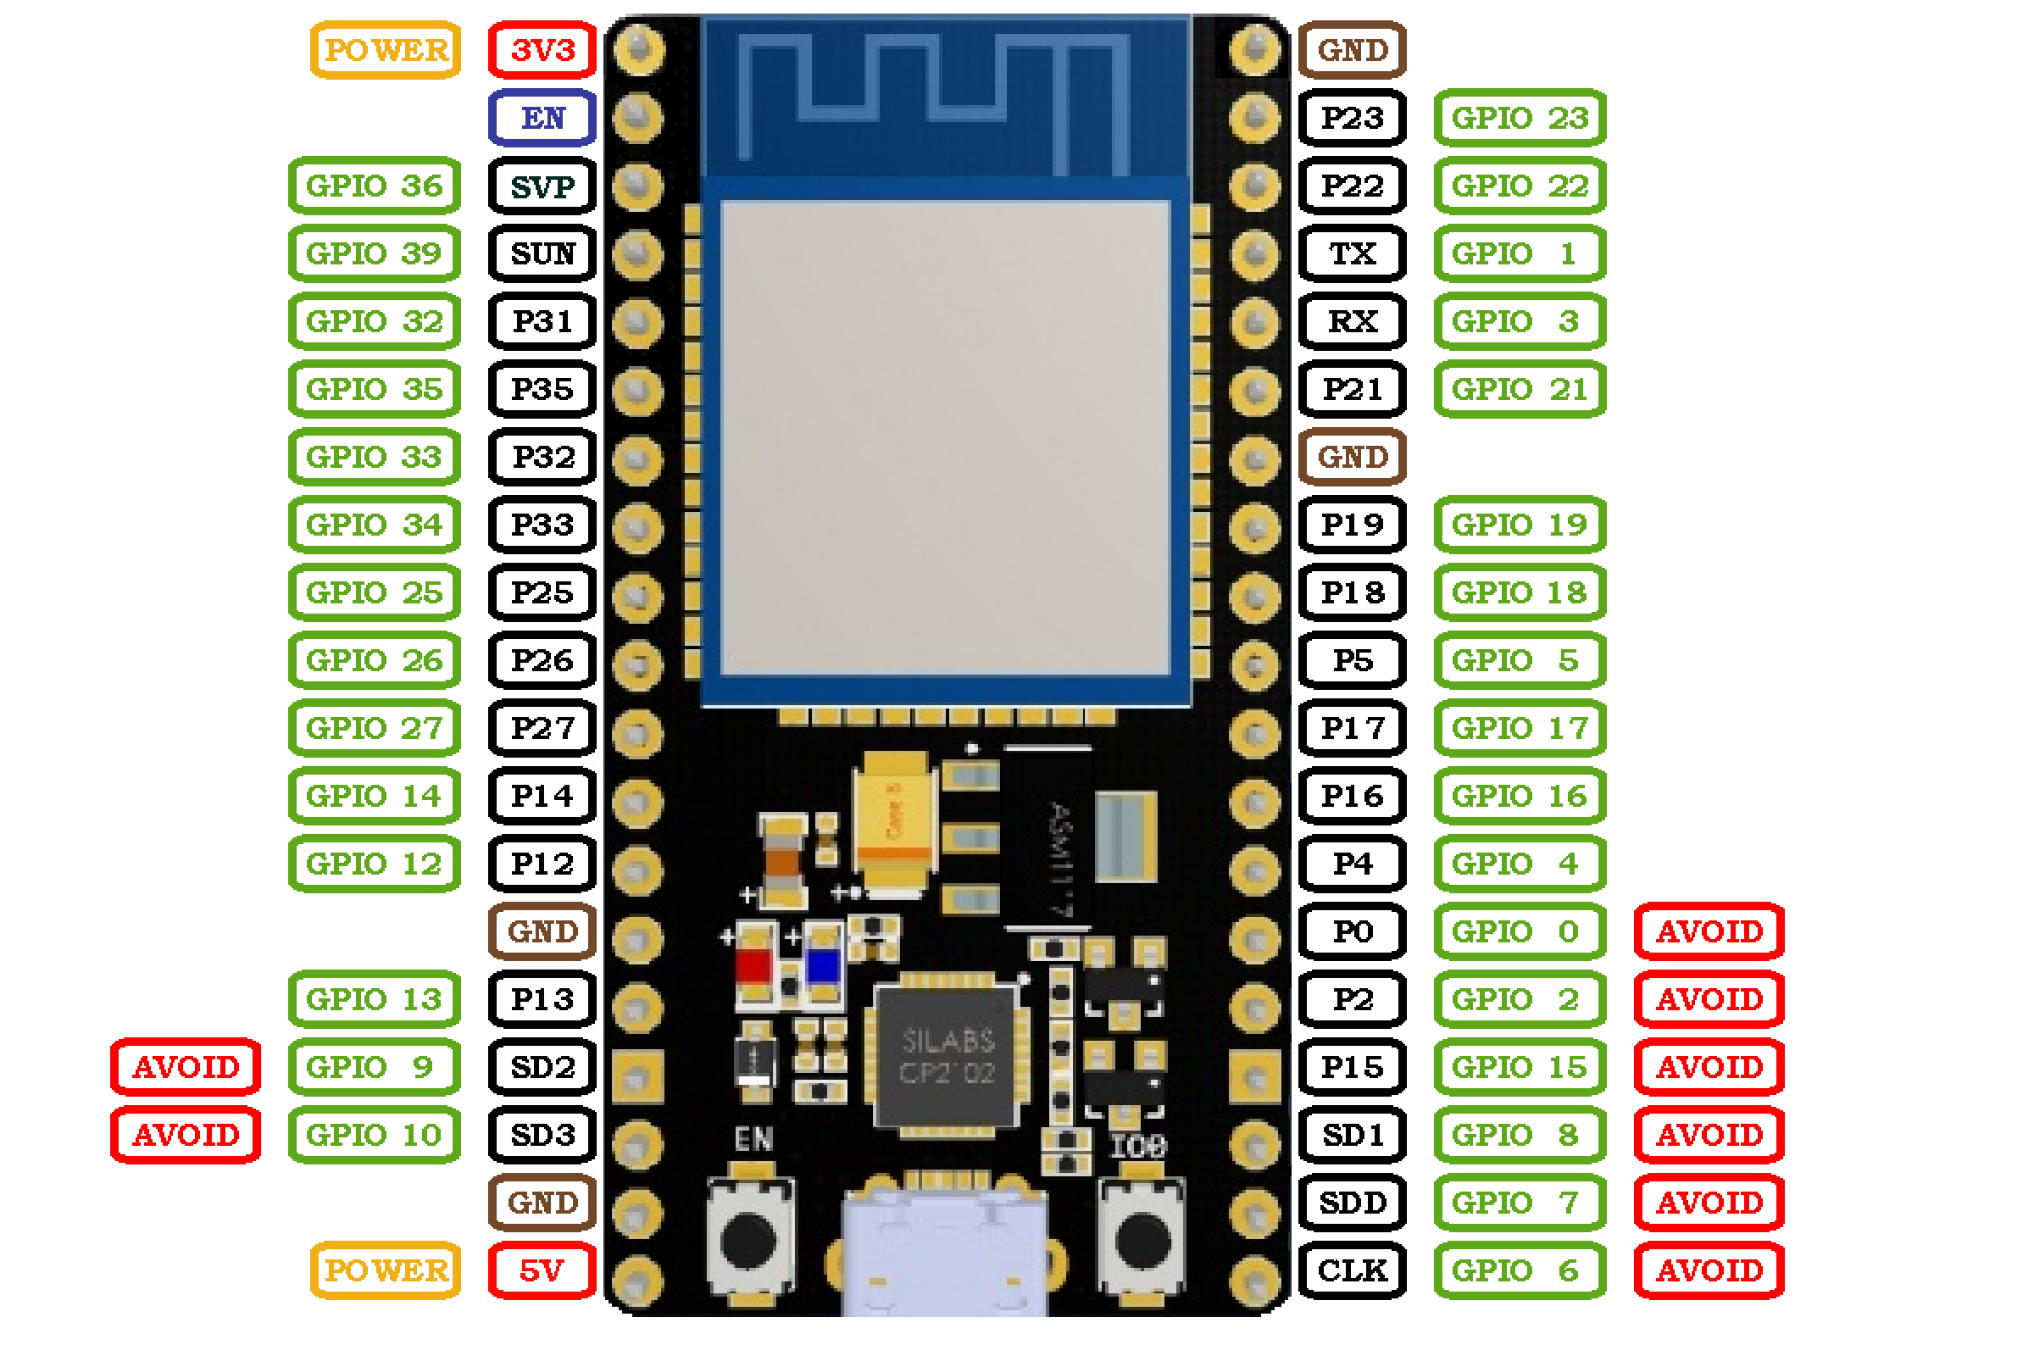

- **AHT20 – sensor**

- Can measure the temperature and the humidity

- **BMP280 – sensor**

- Can measure the temperature and the air pressure

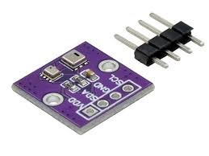 -We use these two in a **combined** sensor:

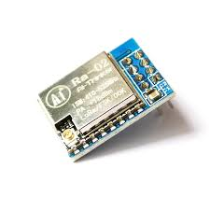 **-BMP280+AHT20:**

**- LoRa SX1278 – radio transmitter (2)**

- A long range, low consumption, radio device.

**2.Initial libraries and firmware:**

First, we had to upload MicroPython to the ESP32s so that they can understand python.

For this we downloaded a library called esptool. (This can be done using the command prompt: *pip install esptool)*

Then we erase the flash by inputting “*esptool erase_flash*”, and we can install the MicroPython firmware. The file that we need can be found here on the official MicroPython website “<https://micropython.org/download/ESP32_GENERIC/>”. Finally, we can upload it to the ESP32s using this command: *“esptool --chip esp32 write_flash -z 0x1000* *<file path>”.*

Then we get the mpremote library by using “*pip install mpremote”*. Then we test if the computer can detect the connected ESP32 with “*mpremote repl”.* After this we expect something like „*Connected to MicroPython at COM<connected port>”*, if this is right, we can start programming.

**3.Testing the sensors and the LoRa:**

Let’s start with the sensors. First, we must download the appropriate drivers, so the microcontrollers can read the sensor data. The AHT20 sensor has and official driver that can be found on this link: <https://raw.githubusercontent.com/targetblank/micropython_ahtx0/master/ahtx0.py>.

The BMP280 lacks an official driver, but David Stenwall has written a working driver that we can use:   
<https://github.com/dafvid/micropython-bmp280/blob/master/bmp280.py>.

Now that we have the drivers, we can start writing the code that tests the sensors. All this code and the other important documents can be found in this github repository. <https://github.com/Grandturkboy/Kaboom_Cansat_2025/blob/main/Scripts/AHT20%26BMP280test.py>.

A képen elektronika, szöveg, Elektromos vezetékek, Elektrontechnika látható

Előfordulhat, hogy az AI által létrehozott tartalom helytelen.Now we can connect the sensor and upload the code to the ESP32. The connections are quite simple:

**Sensor Pin ESP32 Pin**

VDD ==> 3V3

GND ==> GND

SDA ==> P21

SCL ==> P22

Now a little about the code handling of the ESP32. It’s important to note that a local file cannot be run on just a computer, it must be copied to the microcontroller along with the necessary drivers. Some useful command related to this:

- *mpremote ls*  lists the files on the ESP32

- *mpremote cp <file path> :* copy a file to the ESP32

- *mpremote rm <file name>*  remove a file from the ESP32

-*mpremote run <file path>*  run a file on the computer on the ESP32 (very useful for testing)

So, we upload the two drivers and finally run the code.

A képen szöveg, képernyőkép, hold látható

Előfordulhat, hogy az AI által létrehozott tartalom helytelen.The test is a success; the sensors are working.

Now its time for the LoRa. These aren’t extremely different from the sensors other than the code being more complicated. First, we upload the driver to the microcontrollers. The file is found here: <https://github.com/sergio303/micropython-sx127x/blob/master/sx127x.py>. Then we upload it to the ESP32s using the aforementioned “*mpremote cp <file path>”*. Then we can make the connections and connect the antennas (which are ideally around 17-18cm long). The 8 connections that we must make:

A képen Elektromos vezetékek, Elektrontechnika, elektronika, villamosenergia-ellátás látható

Előfordulhat, hogy az AI által létrehozott tartalom helytelen.**LoRa Pin ESP32 Pin**

MISO ==> GPIO19

DIO0 ==> GPIO26

SCK ==> GPIO18

MOSI ==> GPIO23

RST ==> GPIO14

NSS ==> GPIO5

GND ==> GND

VCC ==> 3V3

A képen kábel, Elektromos vezetékek, Elektrontechnika, elektronika látható

Előfordulhat, hogy az AI által létrehozott tartalom helytelen.If the connections have been completed, we can check if the LoRa is being detected by our machine. This snippet of code can be found here: <https://github.com/Grandturkboy/Kaboom_Cansat_2025/blob/main/Scripts/LoRaFXversionCheck.py>. This code prints the chip variant which is usually 18 (0x12). Any other value usually indicates wiring issues.

If this works, we can connect one of the ESP32s with a LoRa and the sensor. This is not difficult, since the only matching pins are the 3V3 and the GND pins. These have been connected using a breadboard.

If this works we can write the semi-final code of the transmitter : <https://github.com/Grandturkboy/Kaboom_Cansat_2025/blob/main/Scripts/Transmitter.py>. This code initiates the LoRa module and configures it to be relatively fast with a long range and sends the sensor data as a string every second. The code also uses CRC to make sure that the other ESP32 can detect when the received packet is corrupted.

After this we set up the receiver. We just upload the LoRa driver and make the connections with the LoRa. Now we can upload the code: <https://github.com/Grandturkboy/Kaboom_Cansat_2025/blob/main/Scripts/Reciever.py>.

This code also initiates and calibrates the LoRa, then starts listening for incoming packets.

We will be naming the main scripts as main.py (“ *mpremote cp <file path> :main.py”)*, because the ESP32s automatically executes “main.py” on startup.

Finally, we can do a final hardware test by naming the receiver and transmitter code main and uploading them to the ESP32s then giving them power. By using the terminal, we can see that the test was successful.

A képen képernyőkép, minta, szöveg, szövet látható

Előfordulhat, hogy az AI által létrehozott tartalom helytelen.